|  |
| --- |
|  |
| ADDC Customer Care & Billing Application System Management Procedure  Version 1.0 |

Document Control

|  |  |
| --- | --- |
| Title: | ADDC Customer Care &Billing Application System Management Procedure |
| Client: | ADDC |
| Version: | V 1.0 |
| Release Date: | Jan 26th, 2013 |
| Author: | Muhammad Ahmad Hussain |
| Security Class: | MediumMedium |
| Distribution: | **Injazat**: DBA and CC&B support teams in ADDC, Account Operational Manager Applications Delivery Manager, Service Assurance Manager, and ADDC Account Manager.  **ADDC**: Customer Solutions Support Section Head. |
| Disclaimer: | This document is uncontrolled when printed. |

Release History

|  |  |  |
| --- | --- | --- |
| Version | Release Date | Approved by |
| 1.0 |  |  |

**EDS INTERNAL DOCUMENT**

Table of Contents

Document Control 2

Release History 2

1 Introduction 5

1.1 Purpose 5

1.2 Background 5

1.3 Audience 5

1.4 Assumptions 5

1.5 Terminology 6

2 Start up and Shutdown Application 7

2.1 Start-up Sequence 7

2.1.1 Starting Applications Instances 7

2.1.2 Starting XAI Instances 7

2.1.3 Starting Batch instance and Thread pools for back ground processing 8

2.1.4 Starting MPL (Multi-Purpose Listener for Integration) 8

2.1.5 Enable Monitoring 9

2.2 Shutdown Sequence 12

2.2.1 Disable Monitoring 12

2.2.2 Shutdown Applications Instances 15

2.2.3 Shutdown XAI Instances 15

2.2.4 Shutdown Batch Instance and Thread pools 15

2.2.5 Shutdown MPL (Multi-Purpose Listener for Integration) 16

2.2.6 Restart the thread pools in case of batch Issues 16

3 User Management in CC&B 17

3.1 Creating a CC&B User in Weblogic 17

3.2 Exporting a weblogic User to all CC&B instances 20

3.3 Changing password for weblogic User 20

3.3.1 Changing password for One Instance 20

3.3.2 Changing password for weblogic User for all CC&B instances 23

3.4 Unlock User 23

3.4.1 Unlock User from Weblogic Console 23

3.4.2 Unlock CC&B application User for all CC&B instances 24

4 Patching and Package Deployment Procedure 26

4.1 How to apply Custom MDC Package 26

4.2 How to apply a single fix (Application or Framework) 27

4.2.1 Application Server Component 28

4.2.2 Database Component 29

4.2.3 Installation Process 30

4.2.4 Database Fix Installation 30

4.2.5 Application Fix Installation 31

4.3 How to apply a group fix (Series of single fixes) 31

5 Refresh Application from production 37

5.1 Assumptions 37

5.2 Application Refresh Procedure 37

5.3 Post cloning Steps 47

5.3.1 Remove Batch Streams Schedules 47

5.3.2 Expire Users from Application 48

5.3.3 Remove MPL Sender Configuration. 48

6 Standby Application Setup 52

6.1 Assumptions 52

6.2 Setup Connectivity to Standby Database 52

## 

# Introduction

## Purpose

This purpose of this document is to describe detailed technical steps to facilitate CC&B day to day operations and activities.

## Background

ADDC is responsible for distributing water and electricity services to all customers in the Emirate of Abu Dhabi (excluding the Al Ain region) with a customer base covering in excess of 400,000 agreements for water and electricity supply. In 2007, a turnkey project that was earlier initiated by ADWEA, implemented Oracle Utilities Customer Care and Billing Solution for ADDC and AADC, and replaced the previously used system. Later, the ADDC CC&B system was handed over to Injazat for support in 2010.

## Audience

This article is meant for ADWEA DBA's to implement technical CC&B activities.

## Assumptions

The following assumptions have been made in this document:

* The application server has all the required prerequisite components like
* Active Perl
* Hibernate
* C3P0
* Java
* Web logic Server
* Oracle Client ( JDBC client)
* Micro Focus Server
* Micro Focus Express
* The document will not cover the installation activities for any of the prerequisites components as they are listed in a separate installation guide which can be accessed from ADWEA Injazat Portal.
* This is a working document and the related teams will continue to revise it and new versions will be released, as needed.

## Terminology

| Term | Definition |
| --- | --- |
| AD | Active Directory | |
| ADWEA | Abu Dhabi Water and Electricity Authority | |
| CC&B | Customer Care and Billing | |
| CSS | Customer Services Solution | |
| HHU | Hand Held Unit | |
| HLD | High Level Design | |
| HP | Hewlett Packard | |
| HP BTO | HP Business Technology Optimization | |
| HPSM | HP Service Manager | |
| LDAP | Light Weight Directory Access Protocol | |
| LL | Low Level Design | |
| MDC | Manila Development Center | |
| MDM | Meter Data Management | |
| MPL | Multi-Purpose Listener | |
| OID | Oracle Internet Directory | |
| OS | Operating System | |
| SAN | Storage Area Network | |
| SOP | System Operating Procedure | |
| TED | Technical Environment Description | |
| WC | Web Centre | |
| OU | Organizational Unit | |
| Wlst | Weblogic Scripting Tool | |

# Start up and Shutdown Application

Application instances are started every fifteen days as a part of preventive maintenance schedule. Also, there might be a need for a restart activity during or after custom packages or fixes are applied to all application instances.

## Start-up Sequence

The starting up procedure of application and XAI instances are as follows.

### Starting Applications Instances

|  |  |  |
| --- | --- | --- |
| Server IP | Script to be executed | Description |
| 10.150.3.45 | /export/home/cissys/wls –e ADDCSPL2 -s | Start Application Instance on port 8600 |
|  | /export/home/cissys/wls –e ADDCSPL3 -s | Start Application Instance on port 8600 |
| 10.150.3.50 | /export/home/cissys/wls –e ADDCSPL -s | Start Application Instance on port 7600 |
|  | /export/home/cissys/wls –e ADDCSPL2 -s | Start Application Instance on port 8600 |
|  | /export/home/cissys/wls –e ADDCSPL3 -s | Start Application Instance on port 9600 |
| 10.150.3.55 | /export/home/cissys/wls –e ADDCSPL2 -s | Start Application Instance on port 8600 |
| 10.150.3.60 | /export/home/cissys/wls –e ADDCSPL -s | Start Application Instance on port 7600 |
|  | /export/home/cissys/wls –e ADDCSPL2 -s | Start Application Instance on port 8600 |
|  | /export/home/cissys/wls –e ADDCSPL3 -s | Start Application Instance on port 9600 |

### Starting XAI Instances

|  |  |  |
| --- | --- | --- |
| Server IP | Script to be executed | Description |
| 10.150.3.45 | /export/home/cissys/wls –e ADDCSPL -s | Start Application Instance on port 7600 |
| 10.150.3.55 | /export/home/cissys/wls –e ADDCSPL -s | Start Application Instance on port 7600 |

### Starting Batch instance and Thread pools for back ground processing

|  |  |  |
| --- | --- | --- |
| 10.150.3.55 | /export/home/cissys/wls –e ADDCBATCH -s | Start Application Instance on port 9600 ( optional should be in silent mode) |
| 10.150.3.55 | /export/home/cissys/thpwkr –e ADDCBATCH -s | Start Thread pools worker |

### Starting MPL (Multi-Purpose Listener for Integration)

|  |  |  |
| --- | --- | --- |
| Server IP | Script to be executed | Description |
| 10.150.3.45 | /export/home/cissys/wls –e ADDCSPL -m | Start MPL on port 7600 ( Primary Instance to start MPL) |
| 10.150.3.55 | /export/home/cissys/wls –e ADDCSPL -m | Start MPL on port 7600 |

Note* (MPL should run only in one server with active passive behaviour)

### Enable Monitoring

#### Applications

Login to site scope

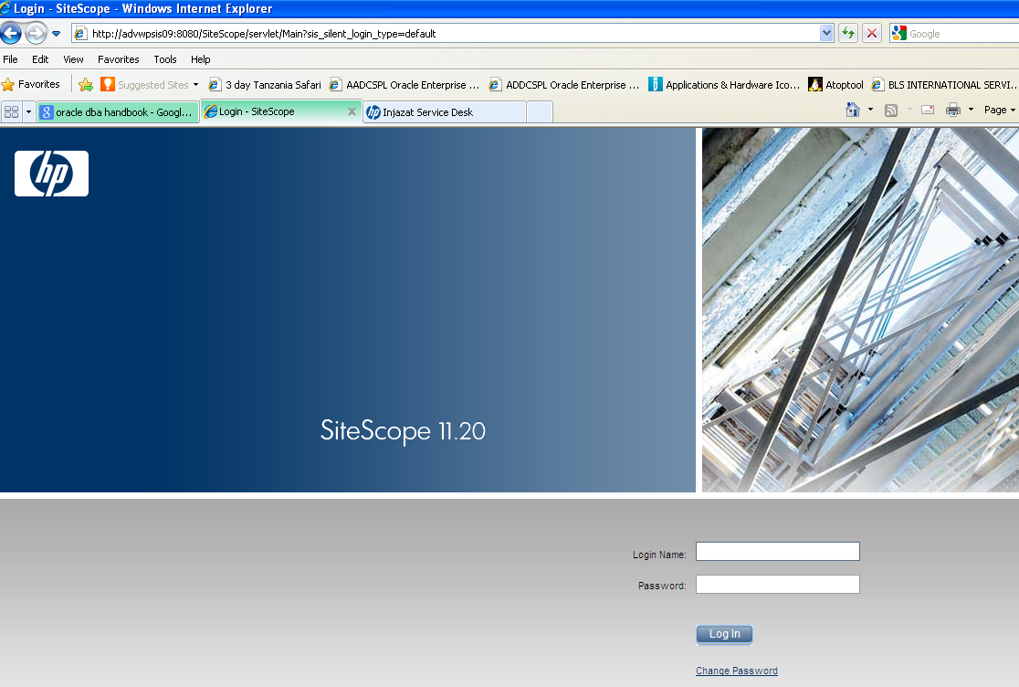

Right click on the application URL select Enable/Disable monitoring

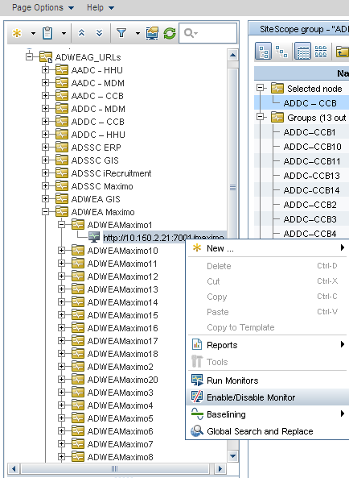

Select appropriate values and then click OK

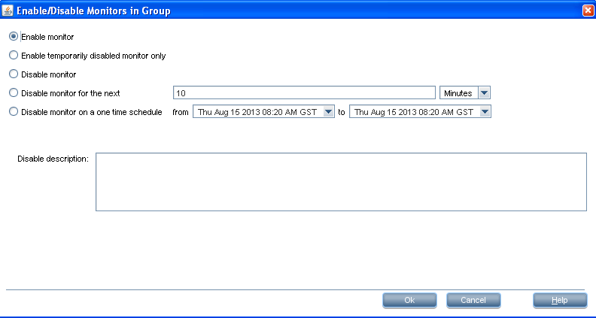

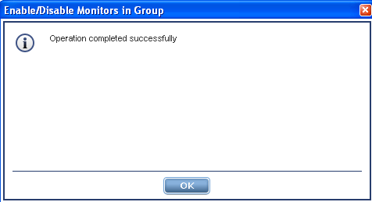

## Shutdown Sequence

### Disable Monitoring

#### Applications

<http://advwpsis09:8080/SiteScope/servlet/Main>

Login to site scope



Right click on the application URL select Enable/Disable monitoring



Select the appropriate values and then click ok

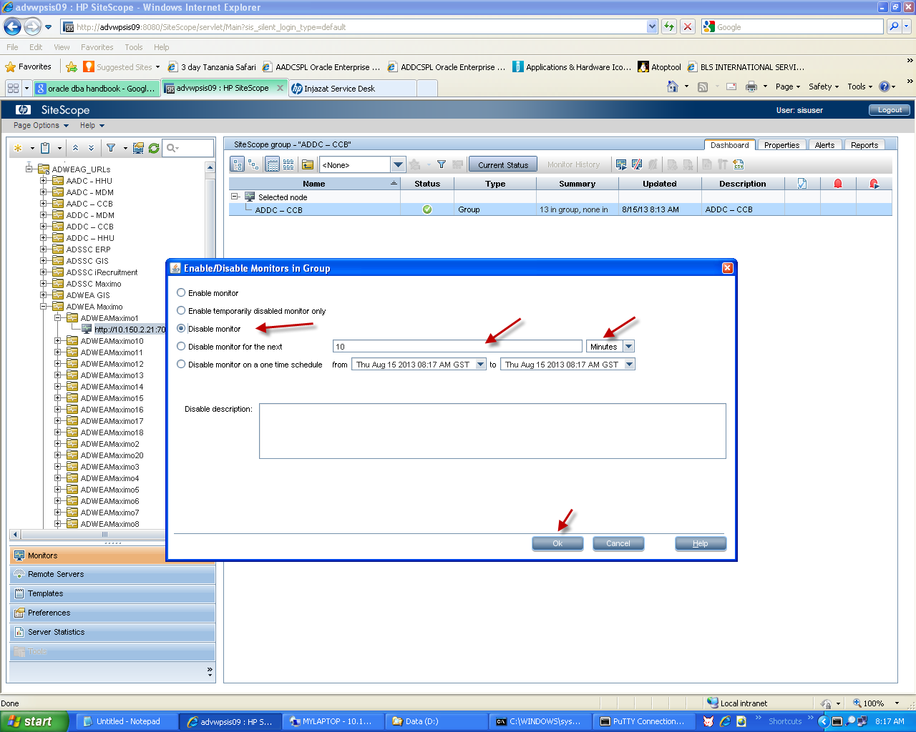



### Shutdown Applications Instances

|  |  |  |
| --- | --- | --- |
| Server IP | Script to be executed | Description |
| 10.150.3.45 | /export/home/cissys/wls –e ADDCSPL2 -c | Stop Application Instance on port 8600 |
|  | /export/home/cissys/wls –e ADDCSPL3 -c | Stop Application Instance on port 8600 |
| 10.150.3.50 | /export/home/cissys/wls –e ADDCSPL -c | Stop Application Instance on port 7600 |
|  | /export/home/cissys/wls –e ADDCSPL2 -c | Stop Application Instance on port 8600 |
|  | /export/home/cissys/wls –e ADDCSPL3 -c | Stop Application Instance on port 9600 |
| 10.150.3.55 | /export/home/cissys/wls –e ADDCSPL2 -c | Stop Application Instance on port 8600 |
| 10.150.3.60 | /export/home/cissys/wls –e ADDCSPL -c | Stop Application Instance on port 7600 |
|  | /export/home/cissys/wls –e ADDCSPL2 -c | Stop Application Instance on port 8600 |
|  | /export/home/cissys/wls –e ADDCSPL3 -c | Stop Application Instance on port 9600 |

### Shutdown XAI Instances

|  |  |  |
| --- | --- | --- |
| Server IP | Script to be executed | Description |
| 10.150.3.45 | /export/home/cissys/wls –e ADDCSPL -c | Stop Application Instance on port 7600 |
| 10.150.3.55 | /export/home/cissys/wls –e ADDCSPL -c | Stop Application Instance on port 7600 |

### Shutdown Batch Instance and Thread pools

|  |  |  |
| --- | --- | --- |
| 10.150.3.55 | /export/home/cissys/wls –e ADDCBATCH -c | Stop Application Instance on port 9600 ( silent mode) |
| 10.150.3.55 | /export/home/cissys/thpwkr –e ADDCBATCH -k | kill Thread pools worker |

### Shutdown MPL (Multi-Purpose Listener for Integration)

|  |  |  |
| --- | --- | --- |
| Server IP | Script to be executed | Description |
| 10.150.3.45 | /export/home/cissys/wls –e ADDCSPL -n | Shutdown MPL on port 7600 |
| 10.150.3.55 | /export/home/cissys/wls –e ADDCSPL -n | Shutdown MPL on port 7600 |

Note* use –k attribute instead of –c for hard killing application and XAI instances.

### 

### Restart the thread pools in case of batch Issues

This is a known issue in CC&B application. At times the batch jobs and streams remain in pending state which needs a restart of thread pool worker. The steps to restart thread pool worker are mentioned below

* Login to the batch application server machine 10.150.3.55
* Run the script along with these parameter to hard kill already running pools

thpwkr –e ADDCBATCH –k

* Login to the database through sqlplus with cisadm user
* Truncate the F1_TSPACE_ENTRY table
* Run the script along with these parameter to start thread pools

thpwkr –e ADDCBATCH –s

Note* : There is script on batch server resetthp.sh which executed all steps listed above.

Note* wls and thpwkr is customized script which is an enhanced version of base scripts.



# User Management in CC&B

All application users created in CC&B application are authenticated at two levels. One is weblogic level and other is at active directory level which is the preferred way. Any domain user who is in CC&B OU can access CC&B application and has control to update their password. Only few type of user like integration, audit and vendor users are created on weblogic level. The section below covers steps on how to create the user at weblogic level and also replicate to all CC&B instances using wlst (Weblogic scripting tool).

## Creating a CC&B User in Weblogic

Any weblogic user created in the application like integration users will be documented and should follow below guide lines.

* + - Login to the weblogic console with system user at URL <http://10.150.3.55:7600/console>

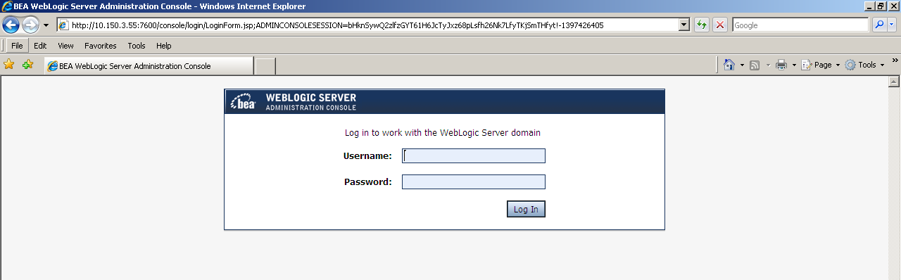

* Navigate to the Security Realm🡪 myrealm

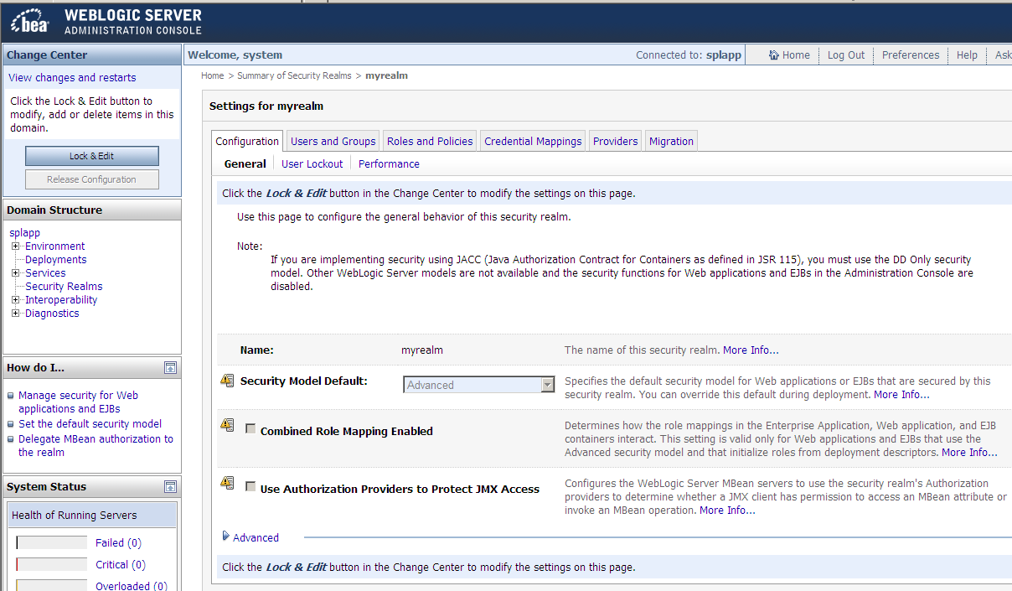

* Click on users and groups
* Click on new

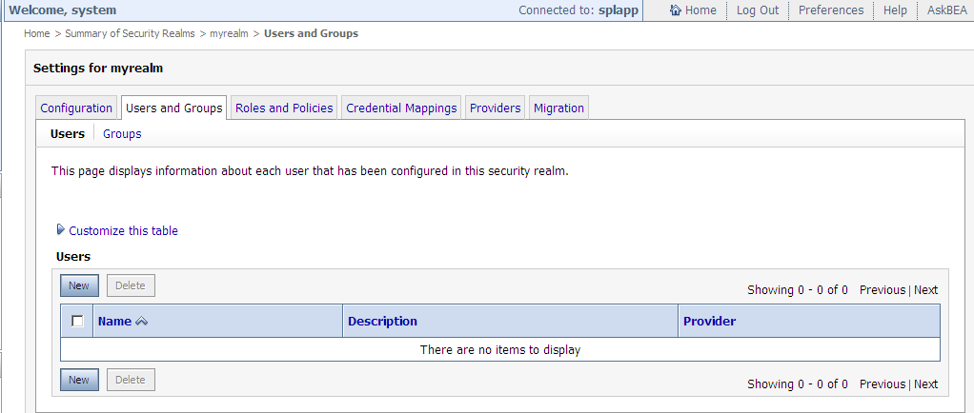

* Provide the information and press OK

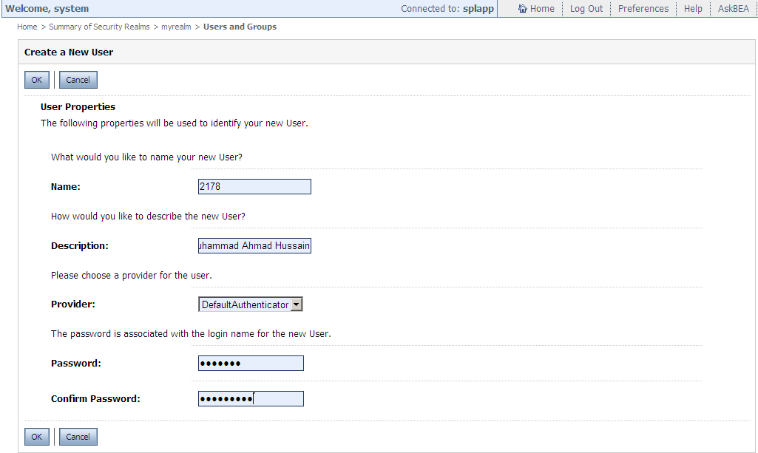

* Click on newly created user and then from group tab assign cisusers group and then save

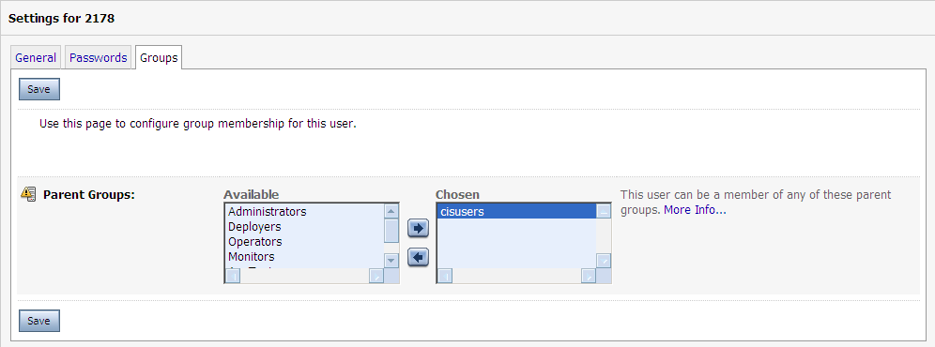

## Exporting a weblogic User to all CC&B instances

* After successfully creating user on this instance, do the following steps to export this newly created user to all remaining application instances using wlst script.
* Login to the application server machine 10.150.3.55
* Run the script /export/home/cissys/userex.sh
* The script exports the users from this instance and imports it to all other instance.



## Changing password for weblogic User

### Changing password for One Instance

* + - Login to the weblogic console with system user at URL <http://10.150.3.55:7600/console>



* Navigate to the Security Realm🡪 myrealm



* Click on “users and groups” tab
* Click on “customize this table” and search for user

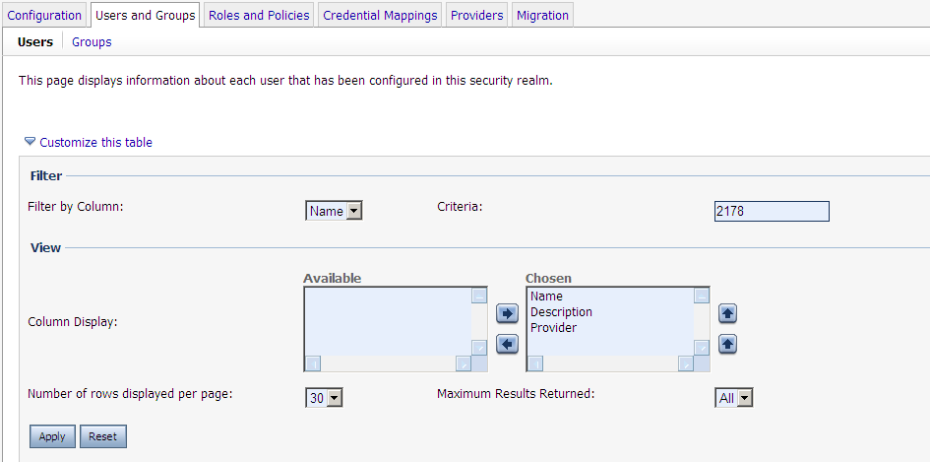

* Select the user from list
* Go password tab and update the password

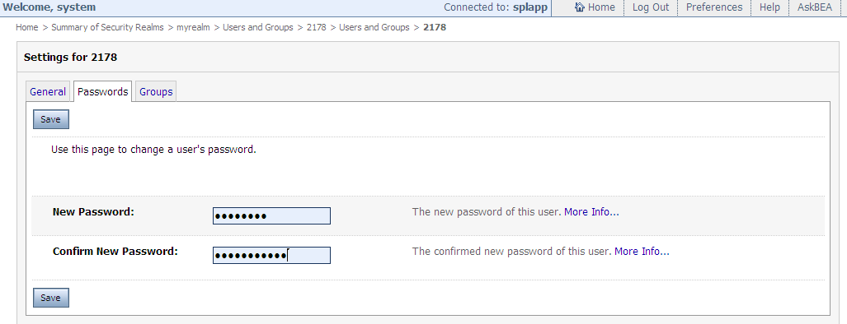

* Click on save button

### Changing password for weblogic User for all CC&B instances

* Login to the application server machine 10.150.3.55
* Run the script /export/home/cissys/userpwd.sh
* Input user id and new password.
* The script replicates the new password to all instances.



## Unlock User

In some of the cases, user id is locked for next 30 minutes due to five invalid password attempts. In that situation, we will unlock the user from weblogic or through wlst script from application server on request of the user. This user is not necessarily the weblogic local user. Any LDAP user can be locked due to five invalid attempts.

### Unlock User from Weblogic Console

* + - Login to the weblogic console with system user at URL <http://10.150.3.55:7600/console>



* Click on splapp ( Domain)
* Click security tab

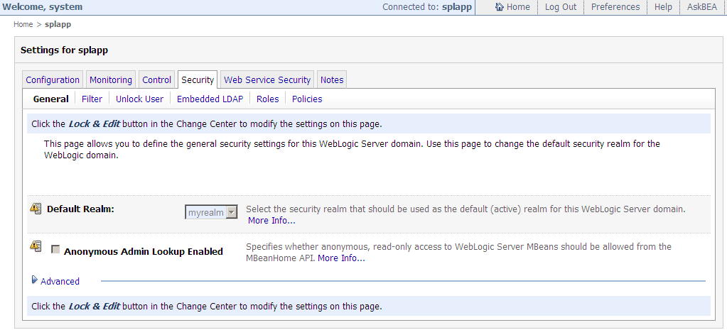

* Click on unlock User nested tab
* Enter the CC&B user id which is locked

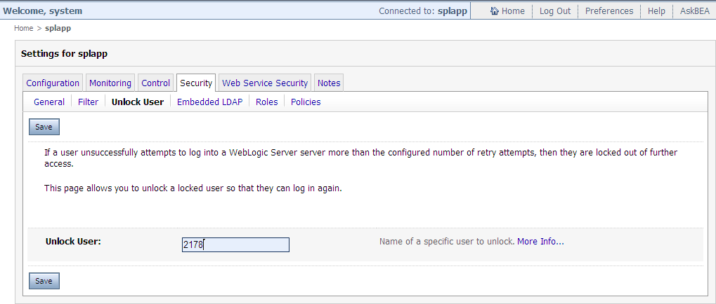

* Click on save

### Unlock CC&B application User for all CC&B instances

* Login to the application server machine 10.150.3.55
* Run the script /export/home/cissys/unlockUserID.sh
* Input user id for any locked user
* The script will replicate the unlock status to all application instances.



# Patching and Package Deployment Procedure

Applying patches and deploying development packages are two commonly carried out activities by the Injazat support teams including the application administration team. Packages are received from Oracle MDC either as a fix to an existing CC&B application issue or as a response to a customized development request. These patches can be applied at the application or the framework level or both.

All the custom (MDC) application enhancement packages, as well as the security, performance and bug fixes are applied on production upon successful confirmation from the application team. Any patch received is first applied on FAT and then moved to UAT for business testing. After confirmation from business, the patch/package is moved for production deployment. The process is followed by a change request CR approved from all the stack holders.

## How to apply Custom MDC Package

::NOTE::

- Ensure that the backup of the Application Environment is taken prior to the beginning of the installation process.

- The installation process start from the batch instance because this instance is running in silent mode for batches only .

- Make sure , you have already disable monitoring from HP site scope before starting deployment proces.

1. Download the package contents of the CM package for ADWEA (ADWEA-B.V2.002.XXX) to the local machine (Windows). Verify the contents of the package, read the Release Notes.
2. FTP the package to the Application Server to the location of CM packages.

$INST_DIR= /export/home/cissys/cm_packages

1. Contents of the package may include 3 parts for installation and should be done in the same order as:  
   • DB Server install [ CMdb_install ]  
   • Read me Document   
   • CM Application Server install [ ADWEA-B.V2.001.XXX-<YY-MM-DD-HHMM> ]
2. Set the Environment using splenviron.sh   
   Ex. /spl/apps1/ADDCSPL/bin/splenviron.sh -e ADDCSPL
3. Stopping the threadpoolworker (Optional)

~/thpwkr -e <ENV> -k

1. Stopping the application environment

~/wls -e <ENV> -k

1. Move to the location of the package $INST_DIR/ADWEA-B.V2.001.XXX
2. Installing DB Server changes, move to the location$INST_DIR/ ADWEA-B.V2.002.XXX/CMdb_install

This folder may contain the following files:

run_set_vars.sh   
run_db.sh  
ADWEA-B_V2_002_XXX_Config.sql

1. Modify the script run_set_vars.sh to replace ‘DUMMY’ with the actual values for:

CISADM – Schema owner (cisadm)  
CISPWD - CISADM login password (*******)  
CISUSERPWD - CISUSER login password(*******)  
ORACLE_SID – Oracle database name (aadcspl or addcspl)  
NLS_LANG – NLS language setting for Arabic (AMERICAN_AMERICA.AR8ISO8859P6)  
  
Grant execute permissions to the script run_db.sh and execute the script

chmod +x run_db.sh

./run_db.sh  
  
Results will be in the Log directory. Verify if run successfully and commit is applied in the end.

1. Installing CM Application Server Changes, this may contain the following folders:

*cobol  
*etc  
*java  
*services  
*splapp

* Set the path for the package installation if not set already from .profile

export INST_DIR=/export/home/cissys/cm_packages

* Switch to the location of the package that contains the folders shown above

$INST_DIR/ADWEA-B.V2.002.XXX/ADWEA-B.V2.002.XXX-<YY-MM-DD-HHMM>

* Execute $CM_DIR/applyCM.sh
* This script must be executed using the full path of the script.
* The script copies the cobol code and java source codes to the appropriate directories and compiles all the related cobol codes and generates the logs the location from where the script was executed i.e. $INST_DIR/ADWEA-B.V2.002.XXX/ADWEA-B.V2.002.XXX-<YY-MM-DD-HHMM>
* It will finally start up the application.
* If used with –n option the script does not try to stop or start the environment. This is useful when multiple packages have to be applied on the same environment.

$CM_DIR/applyCM.sh -n   
where CM_DIR=$INST_DIR/CM_packaging

1. Start the application if not started by applyCM.sh script.
2. Starting the batch scheduler threadpoolpworker

~/thpwkr -e <ENV> -s

## How to apply a single fix (Application or Framework)

Every patch on the V2* platform will have an application server component and an optional

database component. Some patches have pre-requisites and these need to be installed before the patch installation.

### Application Server Component

Check the file “installed_fixes.txt” file in the etc folder to check if there is an entry for the patch number.

If a patch has been installed the installation process will notify you and by pass this patch.

* Step 1 - Download patch from metalink and save to your PC. (For eg. patch 6871983)



* Step 2 – Unzip the contents of file “p6871983_2200_Generic.zip” and save to your PC.



* Step 3 – Unzip the contents of file “MultiPlatform.zip” and save to your PC.



**Step 4 – Go into directory “V2.2.0-6871983_MultiPlatform”.**



**Notes:**

This patch has Application Server and a database component. If the patch does not include directory “database” then no need to complete the database component instructions below.

Read the README.txt file.

The “*.coreq” file contains the patches that will be installed at the same time this patch is

installed. This example does not have a “*.coreq” file.

The “*.prereq” file contains the patches that need to be installed before this patch is installed.

**Step 5 – Follow the instructions in the “AppServer_install.doc” for your platform and product.**

(Use ftp Binary Mode.)

**Notes:**

Check the log files. Also check the contents of the “installed_fixes.txt” file in the etc folder

to check if there is an entry for the patch number. Also, the document “AppServer_install.doc”

contain instructions for performing Group Installs. This allows you to install a group of single fix in one run..

### Database Component

Step 1 – Go into Directory “database\ORACLE”.



Step 2 – Unzip the contents of “CDXPatch.zip” and save to your PC.



**Notes:**

Follow the instructions in the “Database_install.doc”.

You can access the database to see if the entries are in the CI_UT_INSTL and UT_INSTL_DTL

tables in the CISADM schema.

In the CI_UTL_INSTL there should be an entry for the SR_NO = to the patch number.

In the CI_UTL_INSTL_DTL there should be one or more entries with the name of the script that

was executed in the patch.

Example:

SELECT * FROM CI_UT_INSTL WHERE SR_NO = '6973539';



SELECT * FROM CI_UT_INSTL_DTL WHERE SCRIPT_FILE_NAME LIKE '%6973539%';



Warning! It is very important that you adhere to the following order.

1. If the file IR_<Single Fix Name>.prereq exists, it contains the prerequisite single fixes that must be applied BEFORE this single fix. Keep in mind that a prerequisite single fix may itself have prerequisites.

2. Apply the database fix (if applicable) as described in Database_install.doc.

3. Apply the application server fix as described in AppServer_install.doc.

4. If the file IR_<Single Fix Name>.coreq exists, it does not require any additional action during the installation process.

5. If for Framework single fix the file IR_<single fix name>.postreq exists examine it's content and apply listed there single fixes of top application product if applicable to your environment follow the FW single fix installation.

:: Note::

If co-requisites have their own prerequisites, they will be listed in corresponding files named <IR_coreq single fix name>.prereq. In this case you should consider the combined list of prerequisites of all co-requisites as the complete list of prerequisites for the whole selected single fix package.

### Installation Process

-Installation of Database Fix is done from Windows.

- Installation of Application Fix is done from Unix.

### Database Fix Installation

::NOTE::Ensure that a backup of the database is taken prior to the beginning of the installation process.

- The installation process start from the batch instance because this instance is running in silent mode for batches only .

- Make sure , you have already disable monitoring from HP site scope before starting deployment process.

1, To apply single-fix Windows or NT workstation with Oracle Client and able to connect to SPL database....

2, Execute the utility CDXPatch.exe under ..\database\ORACLE\CDXPatch\ in the downloaded patch

3, Provide the Database and user-password details of 'CISADM'(owner of the CC&B Objects)

4, The utility will create the logs for specific database, verify for any errors before proceeding to next.

### Application Fix Installation

::NOTE::

- Ensure that the backup of the Application Environment is taken prior to the beginning of the installation process.

- Make sure to read the README.txt file for any special instructions.

1, Move the <Product name>.<Version number>-<single fix name>.tar.Z to the Unix Server.

2, Extract the contents of this tar.

3, Execute the installSF.sh script to install the patch.

4, After successful installation of the patch and its co-requisite patches, the patch numbers will be appended to the installed_fixes.txt file under $SPLEBASE/etc

## How to apply a group fix (Series of single fixes)

In some cases, we received series of single fixes or one single fix has a chain of pre-requisites. In that case, it’s difficult to apply single fixes one by one on all instances. The Oracle utility customer care and billing has a flexibility to apply all single fixes by using utility installSFgroup

Note:

When preparing the text file with the list of fixes that are to be installed as a group, not all co-requisites of a certain fix have to be included, but including all prerequisites is mandatory. Putting only one co-requisite per patch instead of all co-requisites is enough, with the condition that the skipped Co-requisites aren't also prerequisites of patches to be installed. The utility checks first for missing prerequisites and if it will find prerequisites that are not installed on the environment and not included in the current installation group list as well, it will record them in the file named missprereq, will notify the installer

About the situation and exit the installation. This will happen even though a corequisite of a missing prerequisite exists. Afterwards the patch numbers that are missing

Have to be added to the input file and the group has to be applied one more time. This is why the only co-requisites that may be excluded from the input file are the ones that isn’t also prerequisites of patches to be installed.

The below is an example of implementation of group fix installation. In this example, to apply one fix 9821216 which has one pre-requisite and this has one more prerequisite.

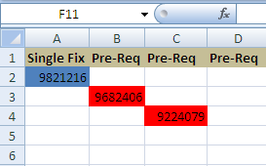

1. Download all three packages and extract in respective folder like FW or CCB.

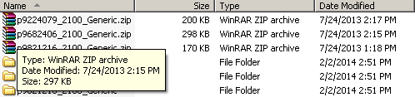

1. Prepare the SR.txt file according to the installation sequence. Pre-requisite patch will always come first.

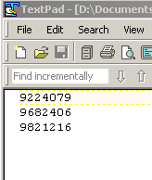

1. Copy the contents in target CC&B unix application server.

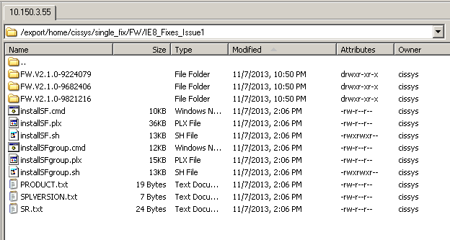

1. Set the Environment using splenviron.sh

/spl/apps1/ADDCSPL/bin/splenviron.sh -e <ENV>

1. Stopping the threadpoolworker (Optional)

~/thpwkr -e <ENV> -k

1. Stopping the application environment

~/wls -e <ENV> -k

1. Run the below command to apply series of fixes using installSFgroup utility.

/export/home/cissys/single_fix/FW/IE8_Fixes_Issue1/installSFgroup.sh -p FW -v V2.1.0 -d /export/home/cissys/single_fix/FW/IE8_Fixes_Issue1

-f /export/home/cissys/single_fix/FW/IE8_Fixes_Issue1/SR.txt

The installSFgroup have the following parameters

-p patch type ( FW or CC&B)

-v Version of the product

-d source directory of all patches

-f input file reference where we specify the patch order

1. The installation starts and tells the status of each patch individually. Verify the status of installation of each patch.

****************************************************************************

See Installation Log in /export/home/cissys/single_fix/FW/IE8_Fixes_Issue1/SR.txt.AADCBATCH.install.log

131205.15:02:02 <info>

131205.15:02:04 <info> Startup /Shutdown logs will go to /spl/apps3/AADCBATCH/logs/system/spl.sh.log

131205.15:02:05 <info>

131205.15:02:05 <info>

Failed to connect to t3://adpupbla01:7600: Destination unreachable; nested exception is:

java.net.ConnectException: Connection refused; No available router to destination

131205.15:02:11 <info>

131205.15:02:11 <info> SCRIPTNAME:checkWLjava: Checking whether Java is Up

131205.15:02:12 <info>

131205.15:02:12 <info>

131205:150212 <info>

131205:150212 <info> ***************************************************************

131205:150212 <info> Validate installation of the Single Fix 9224079

131205:150212 <info> ***************************************************************

131205:150213 <info>

131205:150213 <info> ***************************************************************

131205:150213 <info> About to proceed with the Single Fix 9224079 installation

131205:150213 <info> ***************************************************************

131205:150213 <info>

About to copy /export/home/cissys/single_fix/FW/IE8_Fixes_Issue1/FW.V2.1.0-9224079/data/splapp to /spl/apps3/AADCBATCH/splapp

About to copy /export/home/cissys/single_fix/FW/IE8_Fixes_Issue1/FW.V2.1.0-9224079/data/etc to /spl/apps3/AADCBATCH/etc

131205:150213 <info>

131205:150213 <info> Log file is /export/home/cissys/single_fix/FW/IE8_Fixes_Issue1/FW.V2.1.0-9224079/AADCBATCH.install.log

131205.15:02:13 <info>

131205.15:02:13 <info>

131205:150214 <info>

131205:150214 <info> ***************************************************************

131205:150214 <info> Validate installation of the Single Fix 9682406

131205:150214 <info> ***************************************************************

131205:150214 <info>

131205:150214 <info> ***************************************************************

131205:150214 <info> About to proceed with the Single Fix 9682406 installation

131205:150214 <info> ***************************************************************

131205:150214 <info>

About to copy /export/home/cissys/single_fix/FW/IE8_Fixes_Issue1/FW.V2.1.0-9682406/data/etc to /spl/apps3/AADCBATCH/etc

About to copy /export/home/cissys/single_fix/FW/IE8_Fixes_Issue1/FW.V2.1.0-9682406/data/splapp to /spl/apps3/AADCBATCH/splapp

131205:150214 <info>

131205:150214 <info> Log file is /export/home/cissys/single_fix/FW/IE8_Fixes_Issue1/FW.V2.1.0-9682406/AADCBATCH.install.log

131205.15:02:14 <info>

131205.15:02:14 <info>

131205:150215 <info>

131205:150215 <info> ***************************************************************

131205:150215 <info> Validate installation of the Single Fix 9821216

131205:150215 <info> ***************************************************************

131205:150215 <info>

131205:150215 <info> ***************************************************************

131205:150215 <info> About to proceed with the Single Fix 9821216 installation

131205:150215 <info> ***************************************************************

131205:150215 <info>

About to copy /export/home/cissys/single_fix/FW/IE8_Fixes_Issue1/FW.V2.1.0-9821216/data/splapp to /spl/apps3/AADCBATCH/splapp

About to copy /export/home/cissys/single_fix/FW/IE8_Fixes_Issue1/FW.V2.1.0-9821216/data/etc to /spl/apps3/AADCBATCH/etc

131205:150215 <info>

131205:150215 <info> Log file is /export/home/cissys/single_fix/FW/IE8_Fixes_Issue1/FW.V2.1.0-9821216/AADCBATCH.install.log

131205.15:02:15 <info>

131205.15:02:15 <info>

131205.15:02:15 <info>

131205.15:02:15 <info>

131205.15:02:15 <info>

Java version = 1.5.0_12

Java vendor = Sun Microsystems Inc.

Java OS name = SunOS

Java OS arch = sparc

Java OS version = 5.10

BEADIR=/opt/bea

Version ................ (SPLVERSION) : V2.1.0

Database Type ............... (SPLDB) : oracle

ORACLE_SID ............. (ORACLE_SID) : AADCSPL

NLS_LANG ................. (NLS_LANG) : AMERICAN_AMERICA.AR8ISO8859P6

Environment Name ....... (SPLENVIRON) : AADCBATCH

Environment Code Directory (SPLEBASE) : /spl/apps3/AADCBATCH

App Output Dir - Logs ... (SPLOUTPUT) : /spl/interface1/sploutput/AADCSPL

Build Directory .......... (SPLBUILD) : /spl/apps3/AADCBATCH/cobol/build

Runtime Directory .......... (SPLRUN) : /spl/apps3/AADCBATCH/runtime

131205.15:02:23 <info> Startup/Shutdown logs will go to /spl/apps1/ADDCSPL/logs/system/spl.sh.log

131205.15:02:24 <info> Starting Weblogic Environment on http://adpupbla01:9600

131205.15:02:24 <info> startWebLogic.sh process = 28511

****************************************************************************

1. The installation will create a tmp folder having environment reference name along with installation log.

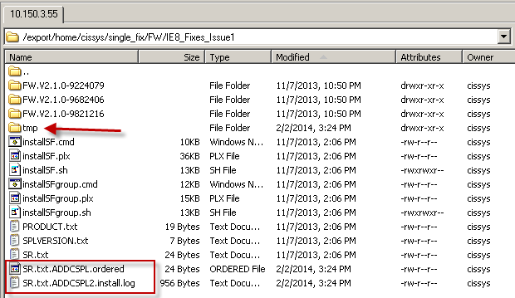

1. The application will automatically start after successful installation.
2. Verify functionality of the patches along with application team.

# Refresh Application from production

The application cloning task is one of the very commonly carried out procedures for CC&B Application. A typical example for the reason behind application cloning is to provide the most recent data and application access to the users to perform their testing. There are different environments for CC&B application like FAT, UAT, SIT and some ad hoc environments for specific functionality testing which might get discarded after completion of that testing.

The request for UAT refresh must be approved by the business and backup might be taken if demanded. The Refresh activity has two parts: one is at the application level and the other is at the database level. The refresh activity at the database level is covered under a separate document under “Database Operational Manual”.

## Assumptions

* The complete database refresh has been done along with prerequisites schemas
* The database is open in read/write mode to connect to target application instance
* The network connectivity has been established between application server and database server

## Application Refresh Procedure

Steps involved in cloning a CC&B application from one server to another, assuming source is the Production environment and target a test environment on a new server that has all the pre-requiste softwares installed.( Refer to the document CC&B Installation Document)

Example used here,

Source Environment: ADDCSPL

Source Server: 10.150.3.50

Target: ADDCTEST

Target Server: 10.150.22.94

1. Cloning of the application is done using ‘cissys’ CC&B Administrator user on the server.
2. On the target server, copy the Production Application base $SPLEBASE in target server directory.

$SPLEBASE=/spl/apps1/base/ADDCSPL

scp -rp cissys@10.150.3.50:/spl/apps1/ADDCSPL .

1. Create an entry for the new environment ADDCTEST in the /etc/cistab file located on the target server.

ADDCTEST::/spl/ADDCTEST:/spl/sploutput/ADDCTEST::N

1. Rename the application base to ADDCTEST

mv ADDCSPL ADDCTEST

1. Create a directory ADDCTEST under /apps/spl/sploutput/ the application logs mount point <SPLDIROUT> for the Application Batch logs.
2. Remove the file dbconnection_overrides.txt from /apps/spl/ADDCTEST/etc.
3. Set the environment for ADDCTEST

/apps/spl/ADDCTEST/bin/splenviron.sh –e ADDCTEST

cissys@ad-css-web3>/apps/spl/ADDCTEST/bin/splenviron.sh -e ADDCTEST

Java version = 1.5.0_12

Java vendor = Sun Microsystems Inc.

Java OS name = SunOS

Java OS arch = sparc

Java OS version = 5.10

BEADIR=/spl/bea

Version ................ (SPLVERSION): V2.1.0

Database Type ............... (SPLDB): oracle

ORACLE_SID ............. (ORACLE_SID): ADDCTEST

NLS_LANG ................. (NLS_LANG): AMERICAN_AMERICA.AR8ISO8859P6

Environment Name ....... (SPLENVIRON): ADDCTEST

Environment Code Directory (SPLEBASE) : /spl/ADDCTEST

App Output Dir - Logs ... (SPLOUTPUT) : /spl/sploutput/ADDCTEST

Build Directory .......... (SPLBUILD) : /spl/ADDCTEST/cobol/build

Runtime Directory .......... (SPLRUN) : /spl/ADDCTEST/runtime

$SPLEBASE=/spl/ADDCTEST

1. Execute the shell script $SPLEBASE/bin/configureEnv.sh to configure the environment variables for ADDCTEST environment. Refer to Directory Name and Installation Options Checklist and Environment Configuration Checklists to set the environment variables.

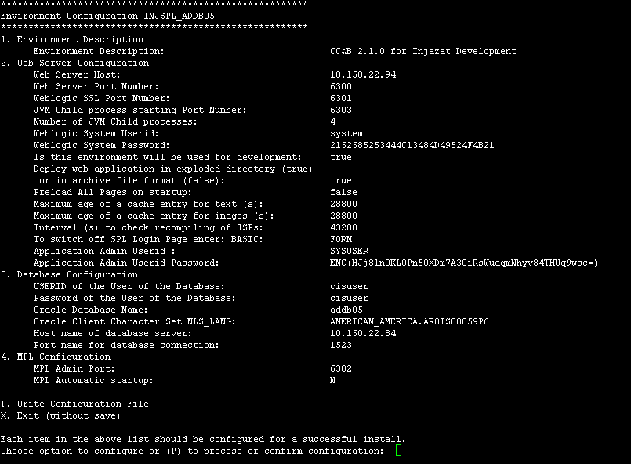

Note: While cloning from one application to another, please note that the passwords for ‘system’ and ‘sysuser’, should not be modified at this stage while configuring other parameters specific for the new target environment. They can be modified later ( see xvi below).

1. Modify other environment variables that cannot be modified by the script directly in ENVIRON.INI file.

From:

SPLOUTPUT=/spl/interface1/sploutput/ADDCSPL

SPLEBASE=/spl/apps1/base/ADDCSPL

SPLENVIRON=ADDCSPL

To:

SPLOUTPUT=/apps/spl/sploutput/ADDCTEST

SPLEBASE=/apps/spl/ADDCTEST

SPLENVIRON=ADDCTEST

1. To modify the memory parameters for Weblogic Server.

Manually modify the file $SPLEBASE/etc/startWebLogic.sh.template with the desired memory settings.

For example, to reduce the memory settings from the a Production clone to Test/Dev environment, modify the file $SPLEBASE/etc/startWebLogic.sh.template file to make the changes permanent, so that whenever the script initialSetup.sh is executed the changes do not get overwritten.

From

MEM_ARGS="-Xms1024m –Xmx2048m -XX:MaxPermSize=300m"

To

MEM_ARGS="-Xms768m -Xmx1024m -XX:MaxPermSize=300m"

**Note:** To change memory parameters for threadpoolworker modify the file $SPLEBASE/bin/threadpoolworker.sh

Default value: MEM_ARGS="-Xms64m -Xmx256m -XX:MaxPermSize=192m "

1. To Remove the RAC database Entry.

This is very important step before we run initial Setup. Make sure you remov the dbconn_override.txt file from $SPLEBASE/etc direcotry.

1. Update the Oracle Logo in the following directory for test environments. This will give an idea for which purpose environment is created.

$SPLEBASE/splapp/applications/root/images

$SPLEBASE/splapp/applications/appViewer/images

$SPLEBASE/splapp/applications/help/ENG/images



1. Execute the shell script $SPLEBASE/bin/initialSetup.sh to update different application configuration files with the new environment variables values and to apply changes made to template files across different folders. This script should be executed always after executing configureEnv.sh

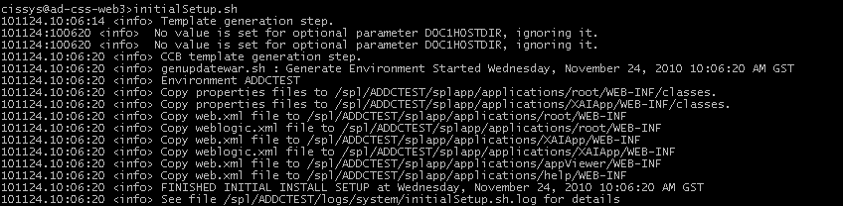

1. Start up the application ADDCTEST using $SPLEBASE/bin/spl.sh start

cissys@ad-css-web3>spl.sh start

101124.10:09:20 <info> Startup/Shutdown logs will go to /spl/ADDCTEST/logs/system/spl.sh.log

101124.10:09:20 <info> Starting Weblogic Environment on http://ad-css-web3:4500

101124.10:09:20 <info> startWebLogic.sh process = 13578

**Note:** Monitor the WebLogic log file till the application is running to check for any errors or slowness while application is coming up.

tail -f $SPLEBASE/logs/system/weblogic.current.log

1. Login to <http://10.150.22.94:6300/> to verfiy if the application came up successfully using ‘sysuser’

User ID: sysuser

Password: <password of source environment>

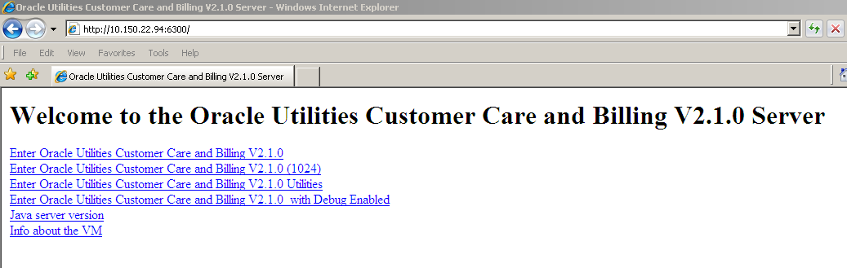

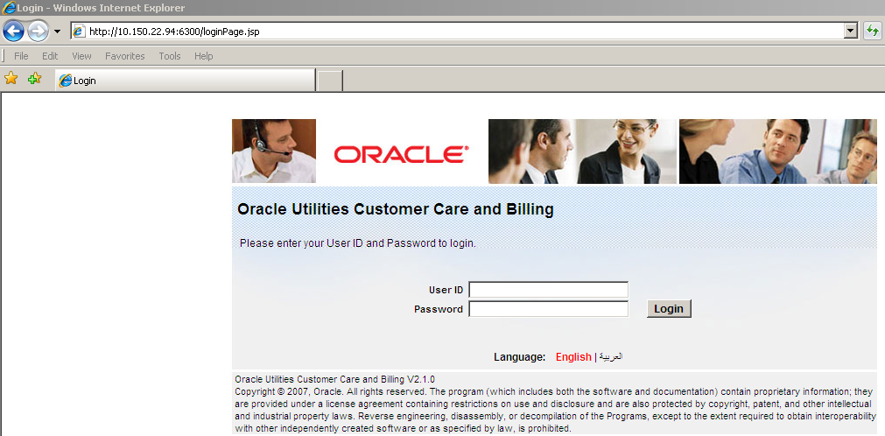

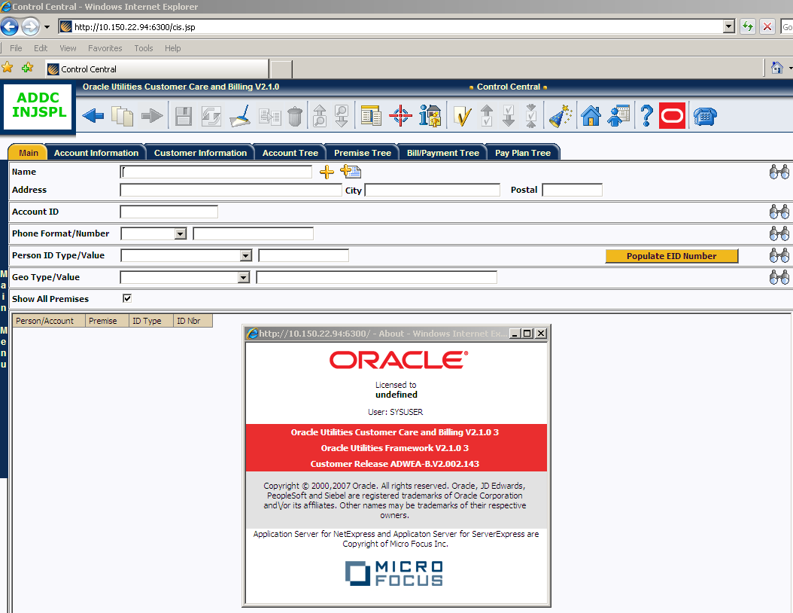

1. Login to <http://10.150.22.94:6300/console> to connect to the Weblogic Admin Console using ‘system’

User ID: system

Password: <password of source environment>

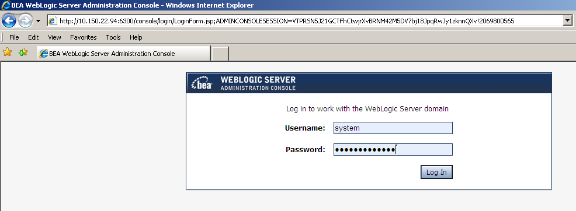

1. To change the password of ‘system’ and ‘sysuser’ from Weblogic Admin Console, go to Security Realms -> myrealm -> Users and Groups

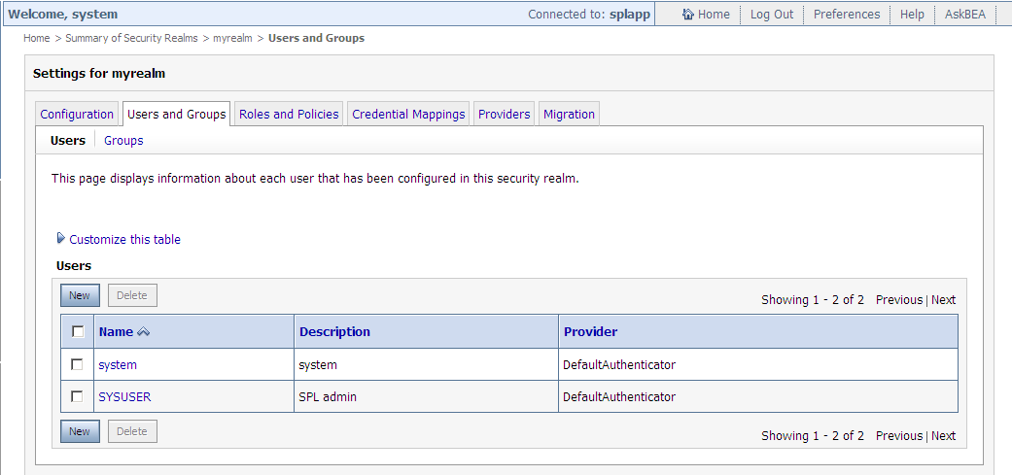

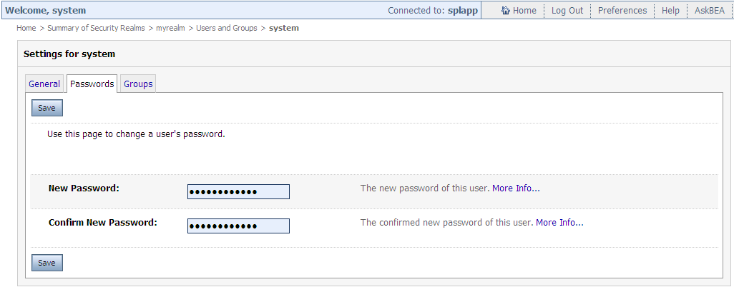

1. After changing the passwords of ‘system’ and ‘sysuser’ on Weblogic Admin Console, the passwords has to be changed on CC&B Application Server by executing configureEnv.sh and initialSetup.sh followed by a restart of the application.
2. To stop the application use $SPLEBASE/bin/spl.sh stop

cissys@ad-css-web3>spl.sh stop

101124.15:32:41 <info> Startup/Shutdown logs will go to /spl/ADDCTEST/logs/system/spl.sh.log

101124.15:32:41 <info> Assuming Weblogic is UP

101124.15:32:41 <info> Stopping Weblogic Environment on advutbla01:6300

Server "myserver" was force shutdown successfully...

101124.15:32:53 <info> Waiting for WEBLOGIC java process to terminate .

101124.15:32:57 <info> Weblogic Shutdown Complete

1. Another way to start and stop the CC&B Application using the ‘wls’ wrapper script which is available on the home directory of ‘cissys’ user.

To start, wls -e ADDCTEST -s

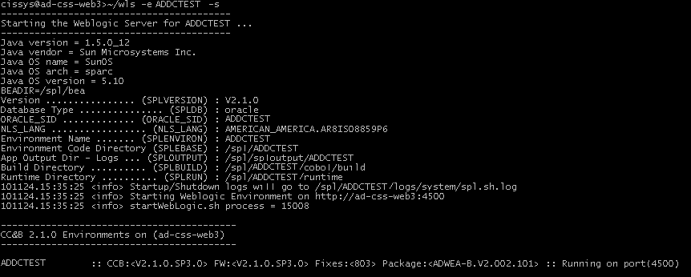

To hard kill, wls -e ADDCTEST -k

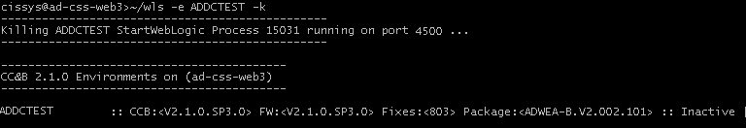

wls -h

USAGE: wls

USAGE: -e ENVIRONNAME

USAGE: -s <To start the Weblogic Server>

USAGE: -c <To stop the Weblogic Server>

USAGE: -k <To hard kill the Weblogic Server>

USAGE: -r <To reboot the Weblogic Server>

USAGE: -m <To start the MPL>

USAGE: -n <To stop the MPL>

USAGE: -h <To display usage>

USAGE: e.g. wls -e MYENVIRON -r <<To reboot the Weblogic Server>>

1. Starting and stopping the Batch scheduler

There are two types of Batch schedulers available in CC&B 2.1.0

1. **Submitbatch** ( Not used ) – the default scheduler provided with the application. Submitbatch is a single process that runs on the application server responsible for starting the batch jobs submitted from the application or from job stream.

To start and stop the submitbatch daemon use the script $SPLRUN/submitbatch.plx provided by the application.

To start,

Execute splenviron.sh, followed by

nohup perl $SPLRUN/submitbatch.plx –s 60 > $SPLSYSTEMLOGS/submitbatch.out 2>&1 &

This will run as a daemon process and wait 60 seconds before checking the run queue again for jobs to run.

To stop,

Executesplenviron.sh, followed by

nohup perl $SPLRUN/submitbatch.plx –k

OR

Do a hard kill on all the parent and child processes of submitbatch process.

1. **Threadpoolworker** - Threadpoolworker is a set of processes that runs on the application server responsible for starting the batch jobs submitted from the application or from the job stream. Threadpoolworker processes allows batch jobs with multiple threads to run at the same time. The threadpoolworker is a standalone process which use application EBASE to get file references.

To start and stop the threadpoolworker processes use the wrapper script thpwkr which is available on the home directory of ‘cissys’ user.

To start, thpwkr -e ADDCTEST -s

This script will set the environment and start the threadpoolworkers configured in the script start_threadpool.sh

In Production, start_threadpool.sh starts 7 threadpoolworkers, one being the primary (-d Y) responsible for polling and assigning batch jobs to other 6 threadpoolworkers (-d N) that executes the batch jobs.

nohup $SPLEBASE/bin/threadpoolworker.sh -p DEFAULT=3 -d Y >$SPLSYSTEMLOGS/threadpool_DEFAULT1_`date +"%Y%m%d_%H%M%S"`.out 2>&1 &

nohup $SPLEBASE/bin/threadpoolworker.sh -p DEFAULT=5 -d N >$SPLSYSTEMLOGS/threadpool_DEFAULT2_`date +"%Y%m%d_%H%M%S"`.out 2>&1 &

nohup $SPLEBASE/bin/threadpoolworker.sh -p DEFAULT=5 -d N >$SPLSYSTEMLOGS/threadpool_DEFAULT3_`date +"%Y%m%d_%H%M%S"`.out 2>&1 &

nohup $SPLEBASE/bin/threadpoolworker.sh -p DEFAULT=5 -d N >$SPLSYSTEMLOGS/threadpool_DEFAULT4_`date +"%Y%m%d_%H%M%S"`.out 2>&1 &

nohup $SPLEBASE/bin/threadpoolworker.sh -p DEFAULT=5 -d N >$SPLSYSTEMLOGS/threadpool_DEFAULT5_`date +"%Y%m%d_%H%M%S"`.out 2>&1 &

nohup $SPLEBASE/bin/threadpoolworker.sh -p DEFAULT=5 -d N >$SPLSYSTEMLOGS/threadpool_DEFAULT6_`date +"%Y%m%d_%H%M%S"`.out 2>&1 &

nohup $SPLEBASE/bin/threadpoolworker.sh -p DEFAULT=5 -d N >$SPLSYSTEMLOGS/threadpool_DEFAULT7_`date +"%Y%m%d_%H%M%S"`.out 2>&1 &

To stop, thpwkr -e ADDCTEST -k

This will hard kill all the processes of the threadpoolworkers including the cobjruns

## Post cloning Steps

Before starting the newly cloned environment, there are some post cloning steps which should be under consideration

### Remove Batch Streams Schedules

Before starting the threadpoolworker on any cloned environment, execute the following sql statements on the DB to remove all future schedules for Batch jobs. If this is not done, when the threadpoolworker is started all the batches will start together impacting performance on the cloned environment.

DELETE FROM cisadm.ci_wf_proc_sched_k

WHERE wf_proc_sched_id IN (SELECT wf_proc_sched_id

FROM cisadm.ci_wf_proc_sched

WHERE wfp_sched_stat_flg = 'P');

DELETE FROM cisadm.ci_wf_proc_sched

WHERE wfp_sched_stat_flg = 'P';

DELETE FROM cisadm.ci_batch_job_k

WHERE batch_job_id IN (SELECT batch_job_id

FROM cisadm.ci_batch_job

WHERE batch_job_stat_flg = 'PD');

DELETE FROM cisadm.ci_batch_job

WHERE batch_job_stat_flg = 'PD';

### Expire Users from Application

This is not applicable to all environments. Usually this step is performed in development environment to restrict end user accessibility.

#### 

Set the expiration date of the user ids on SC_USR_GRP_USR table to current sysdate or past date to avoid the access of users to cloned environment.

Eg.

UPDATE sc_usr_grp_usr

SET expiration_dt = TO_DATE ('28-Nov-2100', 'DD-MON-YYYY')

WHERE user_id IN ('CDX', 'SYSUSER', 'CISREAD');

### Remove MPL Sender Configuration.

This is very important step to remove the production MDM web service call from CC&B. The configuration is inherited from production.

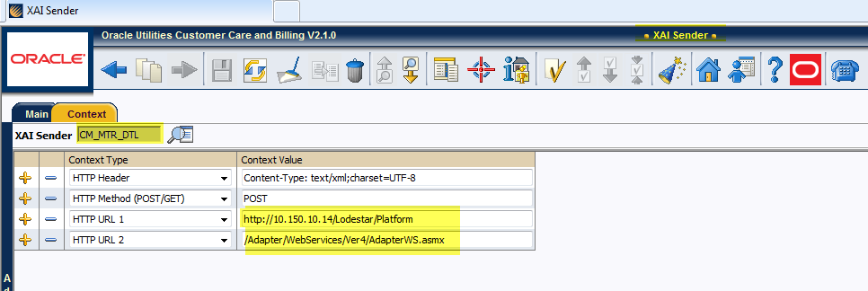

Update CI_XAI_SENDER

set active_sw = 'N';

update CI_XAI_SNDR_CTX

set ctxt_val = '-----'

where sender_ctxt_flg like 'HTU%';

1. Update Feature Configuration Table to remove sender details :

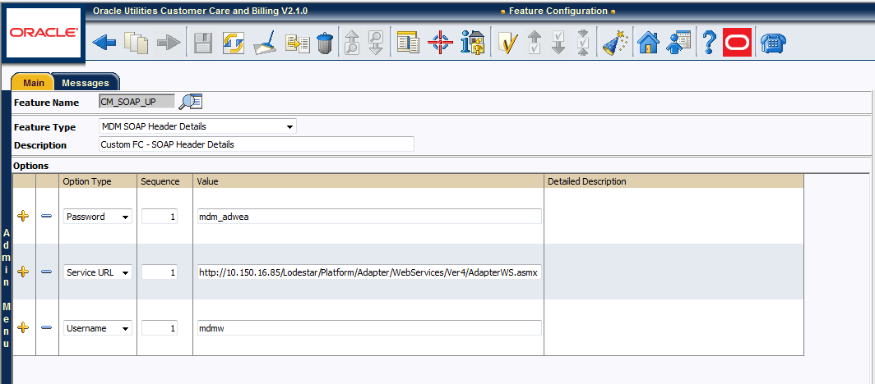

Update CI_WFM_OPT

Set WFM_OPT_VAL=’---‘

Where WFM_NAME=’CM_SOAP_UP’;

1. Database Parameter Settings

alter system set optimizer_index_caching=85 scope = both;

alter system set optimizer_index_cost_adj=15 scope = both;

alter system set open_cursors=10000 scope = both;

1. Update DOC1 Algorithm Reference

update /*** 47 rows **/ CI_ALG_PARM

set alg_parm_val = replace (alg_parm_val,'/CCB_DOC1_PRD_Share/','/CCB_DOC1_UAT_Share/')

where alg_parm_val like '/CCB_DOC1_PRD_Share/%';

1. Update Emirates ID Configuration

Make sure you have Updated the feature configuration and location of Emirates ID photo in feature configuration and UI Map in newly refreshed application.

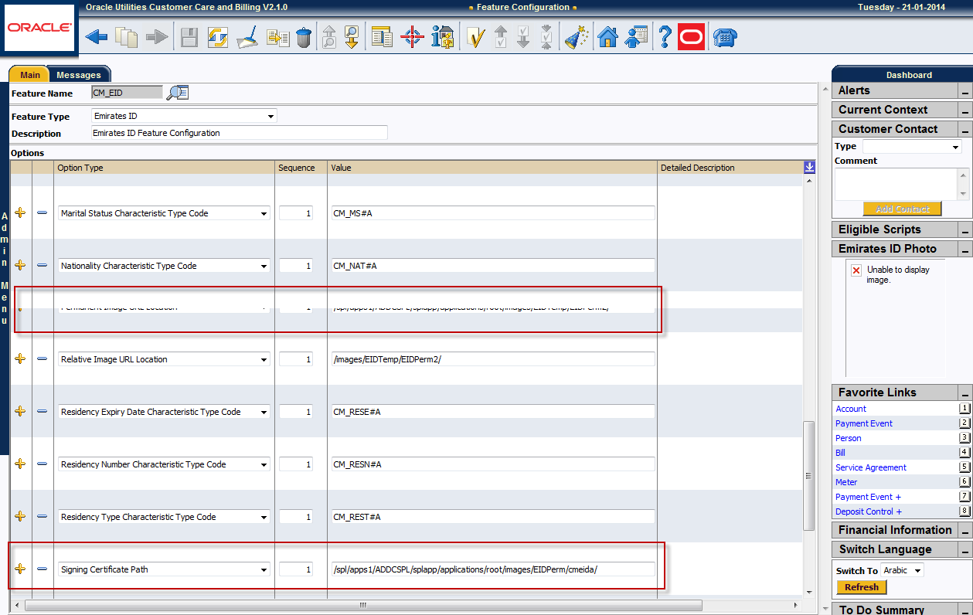

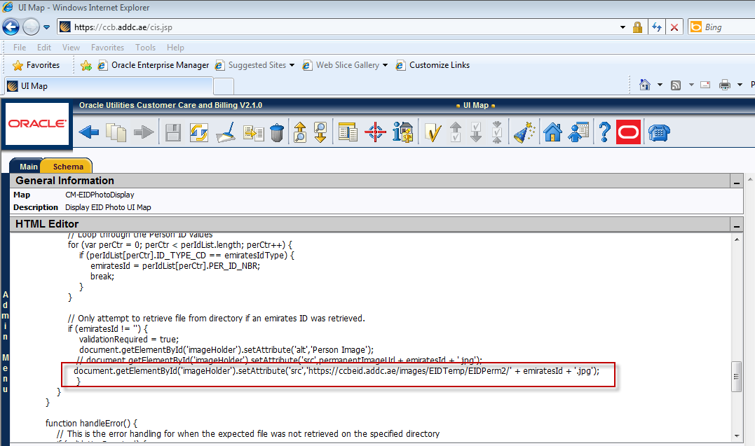

# Standby Application Setup

Like the other critical IT Applications, the infrastructure components of ADDC CC&B application are hosted across two datacentres to provide a higher level of application’s availability, and mainly in case of a need to fully shutdown one datacentre. These two datacentres are ADWEA Datacentre and ADDC Datacentre. The CCB database’s two primary nodes are located at ADDC datacentre and the standby database node is running at ADWEA DC. Three application servers are running in ADDC DC along with a dedicated XAI instance and one application server having batch and dedicated XAI instance is running in ADWEA DC.

The standby database node, running in ADWEA datacentre, is being synchronized with the primary node at ADDC datacentre using maximum performance approach. In case of a planned or unplanned full datacentre shutdown at ADDC, switch over to the nodes in ADWEA datacentre can be quickly arranged to ensure that the CC&B application is made available to end users with minimum downtime. As per the records of the related changes, the switchover or failover of CC&B application and database to the ADWEA DC nodes is completed with a full downtime of 30 minutes.

## Assumptions

* The standby database is completely synchronized with primary database
* The database switch over has been done which is covered under CC&B database operation Manual.
* The standby database is open with read/write access for application
* The network connectivity is done from application server to standby database server.
* Monitoring is disable from both HP site scope and BSM .

## Setup Connectivity to Standby Database

Example used here,

Application Instance Environment: ADDCSPL

XAI Instance Environment: ADDCSPL2

Batch Instance Environment: ADDCBATCH

Application Server IP : 10.150.3.55

Database Server IP : 10.150.7.40

1. Shutdown all application instances on the other nodes.
2. Login as cissys “application admin” user to 10.150.3.55
3. Make sure all three instances are shutdown prior to configuring standby database.
4. Set the environment for ADDCSPL

bash-3.00$ . /spl/apps1/ADDCSPL/bin/splenviron.sh -e ADDCSPL

Java version = 1.5.0_21

Java vendor = Sun Microsystems Inc.

Java OS name = SunOS

Java OS arch = sparc

Java OS version = 5.10

BEADIR=/opt/bea

Version ................ (SPLVERSION) : V2.1.0

Database Type ............... (SPLDB) : oracle

ORACLE_SID ............. (ORACLE_SID) : ADDCSPL

NLS_LANG ................. (NLS_LANG) : AMERICAN_AMERICA.AR8ISO8859P6

Environment Name ....... (SPLENVIRON) : ADDCSPL

Environment Code Directory (SPLEBASE) : /spl/apps1/ADDCSPL

App Output Dir - Logs ... (SPLOUTPUT) : /spl/interface1/sploutput/ADDCSPL

Build Directory .......... (SPLBUILD) : /spl/apps1/ADDCSPL/cobol/build

Runtime Directory .......... (SPLRUN) : /spl/apps1/ADDCSPL/runtime

1. Go to $SPLEBASE/etc and backup ENVIRON.INI file

bash-3.00$ cp ENVIRON.INI ENVIRON.INI_bkp_orig

1. Rename dbconn_override.txt which is used to connect only with RAC database. Make sure this file is not be accessible with it’s orignal name otherwise , setup will write the configuration of RAC database in ENVIRON.INI file.

bash-3.00$ mv dbconn_override.txt dbconn_override.txt4rac

1. Execute the shell script $SPLEBASE/bin/configureEnv.sh to configure the environment variables for ADDCSPL environment. Refer to Directory Name and Installation Options Checklist and Environment Configuration Checklists to set the environment variables.

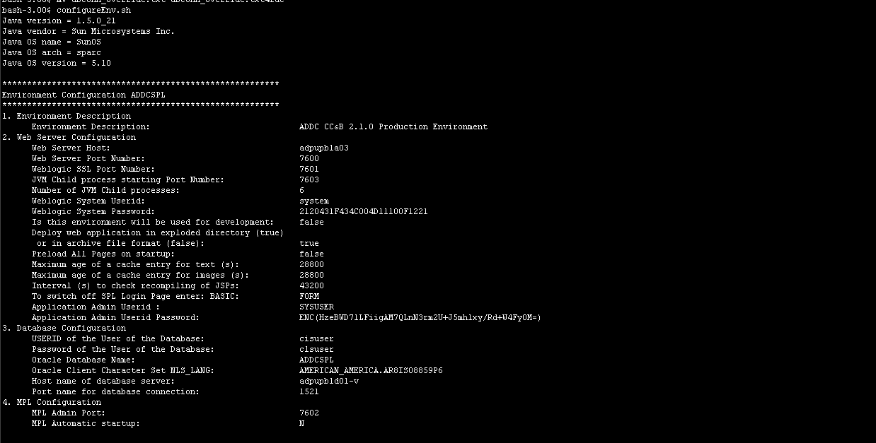

1. Update the following parameter under database configuration

**3. Database Configuration**

USERID of the User of the Database: cisuser

Password of the User of the Database: *********

Oracle Database Name: ADDCSPL_STBY

Oracle Client Character Set NLS_LANG: AMERICAN_AMERICA.AR8ISO8859P6

Host name of database server: 10.150.7.40

Port name for database connection: 1521

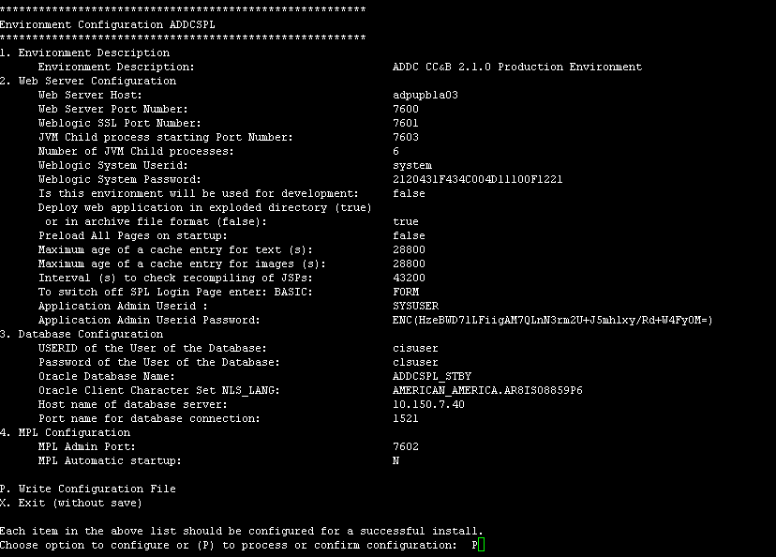

1. Type “P” to process the new setup.
2. This will update the configuration information in ENVIRON.INI file.
3. Execute the shell script $SPLEBASE/bin/initialSetup.sh to update different application configuration files with the new environment variables values and to apply changes made to template files across different folders. This script should be executed always after executing configureEnv.sh



1. Start up the application ADDCSPL using $SPLEBASE/bin/spl.sh start

bash-3.00$> spl.sh start

101124.10:09:20<info>Startup/Shutdown logs will go to /spl/apps1/ADDCSPL/logs/system/spl.sh.log

101124.10:09:20 <info> Starting Weblogic Environment on http:// adpupbla03:7600

101124.10:09:20 <info> startWebLogic.sh process = 13578

**Note:** Monitor the WebLogic log file till the application is running to check for any errors or slowness while application is coming up.

tail -f $SPLEBASE/logs/system/weblogic.current.log

1. Login to CC&B application instance and perform some navigation to check the performance of newly switched application.

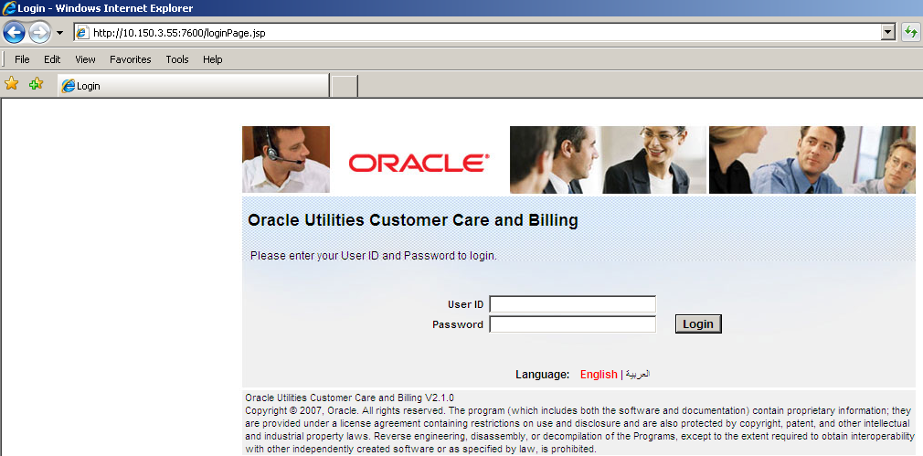

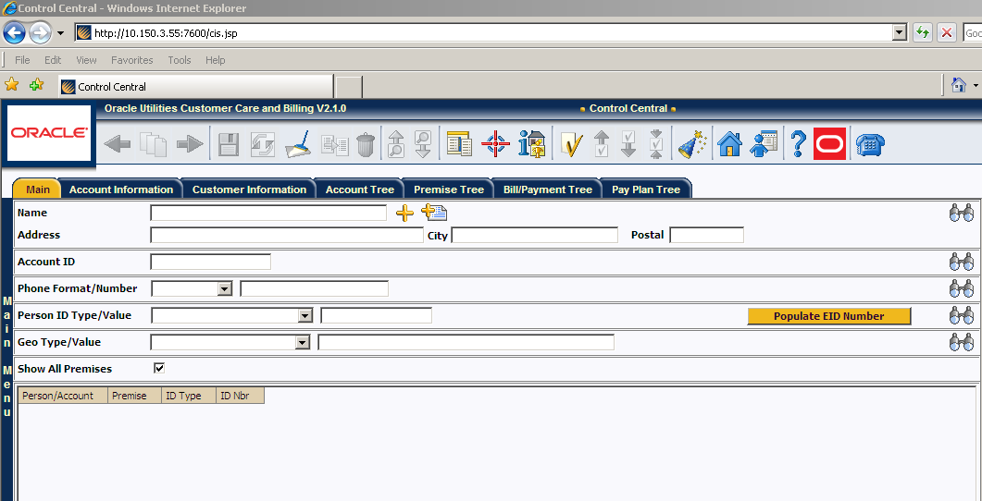

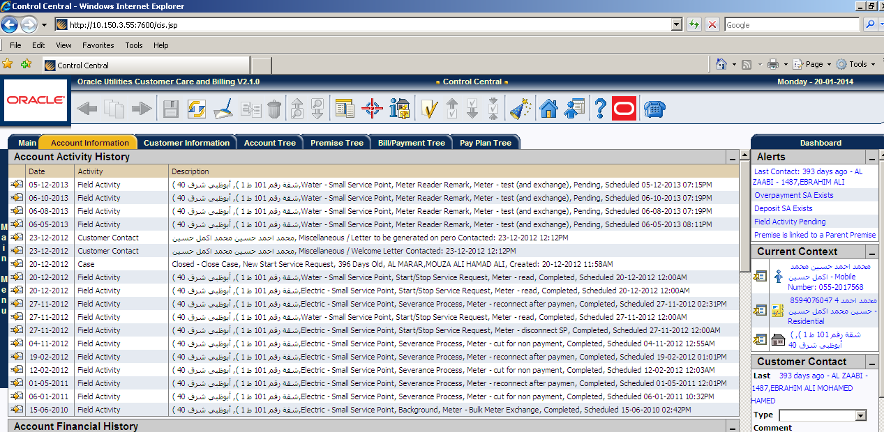

1. Start the MPL using XAI instance

wls –e ADDCSPL -m

1. The same process will be followed for application instance ADDCSPL2 and batch instance.
2. Start the application instance

wls –e ADDCSPL2

1. Start the Batch Instance ( optional )

wls –e ADDCSPL2

1. Start the thread pools using Batch instance.

thpwkr –e ADDCBATCH –s